 A 7-Segment display is a useful electronic component use to produce numeric, alphabetic and some non-alphabetic symbols using a specific arrangement of LEDs as shown in figure here.

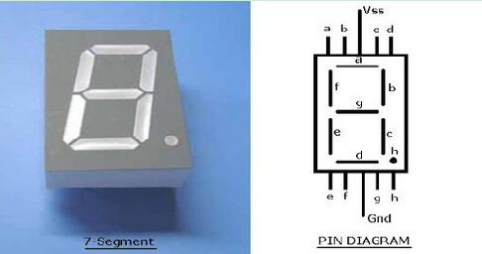

                    A 7-Segment display has 10-Pins representing each **a**, **b**, **c**, **b**, **e**, **f**, **g** and **h** LEDs respectively along with two extra pins for **GND** and **VSS**. following shown an original 7-Segment display device along with its pin diagram. LED **h** is also denoted by symbol **dp**.

Since these are basically LEDs arranged as a group they can either have anode in common or cathode.

Seven Segment are available in two configuration - **(1)** Common Anode **(2)** Common Cathode.

Here common anode seven segment display is used because the output current of the microcontroller is not sufficient enough to drive the LED’s, similar to the case of driving an LED. The circuit diagram shows the connections of seven segment to the controller. The pins a to g of the Seven Segment are connected to the Port P2 of the microcontroller.

